EAST PANHANDLE REGIONAL SCIENCE AND ENGINEERING FAIR
SPONSORED BY
OKALOOSA COUNTY SCHOOL DISTRICT

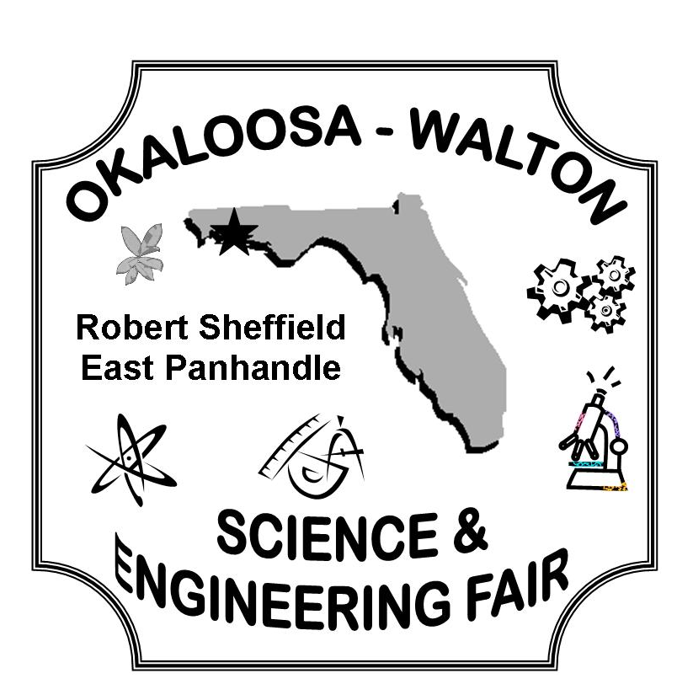
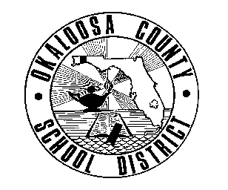
December 9, 2014

To Whom It May Concern:

The East Panhandle Regional Science and Engineering Fair showcases the science, technology, engineering, and mathematics (STEM) research of middle and high school students from Okaloosa and Walton counties. On February 4th nearly 300 students will display their projects and over 100 judges will evaluate their presentations. An awards ceremony will be held on February 17th to recognize student achievement. Several of the students will be recognized for their efforts by receiving place awards; however, many more students will only receive recognition by Special Awards. Due to the nature of our area, generally those in the engineering categories have much more opportunity to receive awards. We hope that this year students in other categories will have the same opportunities for recognition.

Please consider joining with us in this endeavor by sponsoring a Special Award in one or more of the other categories. For your consideration, we have attached a categories list. Thanks to all who have generously contributed in the past…without your help this undertaking could never be accomplished.

Very Best,

Neely Calhoun
Fair Director
850-833-4120

